**Get up to $1,500 to start a Community Emergency Hub**

**In partnership with the Department of Neighborhoods, the Seattle Office of Emergency Management is offering up to $1,500 in mini-grants for up to 12 neighborhoods to support Community Emergency Hub development.**

**Important Dates**

* Monday, August 22, 2016 **Application Open**
* Friday, October 28, 2016 **Application Deadline**

**What is a Community Emergency Hub?**

* A gathering place designated by community residents
* Organized and managed by local neighbors
* A way to coordinate information and resources after disaster
* An important part of how people could help each other when City resources are overwhelmed
* A way to encourage emergency preparedness in your neighborhood
* A way to connect and train with others
* And so much more!

**Project Requirements**

Proposed Hub projects must:

* Maintain a primary contact (and backup, if possible) with Seattle Office of Emergency Management
* Have at least 3 to 5 people as a core workgroup. Agree to exchange information and meet at a designated location.
* Designate a meeting location – not inside a City-owned building.
* Attend a Hub Orientation offered by the Seattle Office of Emergency Management
* Display placard, signage or other designator stating this is a Community Emergency Hub

**Preference**

Preference will be given to projects that:

* are located in a current “emergency hub desert area” (Downtown, Capitol Hill, Central, East, Beacon Hill and NE Seattle)
* recruit neighbors as volunteers (e.g. community members who live or work close to the project site)
* partner with neighborhood organizations, nonprofits, and/or businesses
* take advantage of City programs (e.g., [Adopt-a-Street](http://www.seattle.gov/util/EnvironmentConservation/OurCity/AdoptaStreet/index.htm), [Summer Paint Out](http://www.seattle.gov/util/EnvironmentConservation/GetInvolved/CleanUpGraffiti/SummerPaintOut/index.htm), [Tree Ambassador](http://www.seattle.gov/trees/treeambassador.htm), [Night Out](http://www.seattle.gov/police/Nightout/default.htm), etc.)
* improve the safety and/or appearance of a public space or structure

**Instructions**

Please type or print your answers to **all** sections (1 through 5) in the spaces provided. In Section 6, include photos or links to photos of the proposed project area. **Incomplete applications will delay grant awards**.

**Note**: Please attach additional pages if necessary. Paper applications available on request.

Completed applications must be submitted **no later than 5:00 p.m. PST on** **Friday, Oct 28, 2016**. Applications can be submitted via email or in person to the address below. **Please note, applications cannot be mailed in to the Office of Emergency Management or the Department of Neighborhoods.**

Please submit applications in person to:

Seattle Office of Emergency Management

Attn: Hub in a Box

105 5th Avenue, Suite 300

Seattle, WA 98104

Or submit them via email to [debbie.goetz@seattle.gov](mailto:debbie.goetz@seattle.gov)

**If you missed the application deadline or you have general questions:**

Please contact Debbie Goetz, Community Planning Coordinator, at the above email or call (206) 684-0517.

Visit [www.seattle.gov/emergency](http://www.seattle.gov/emergency) to learn more about Community Emergency Hubs and what local Hub Captains are doing in their own neighborhoods.

**Section 1:** *Applicant Information*

|  |  |
| --- | --- |
| 1. **Organization Name:** |  |
| 1. **Project Contact Person:** |  |
| 1. **Phone Number:** |  |
| 1. **Email Address:** |  |
| **Project Address:** |  |

**Section 2:** *Project Information*

|  |
| --- |
| **Please provide a general overview of your Hub and how it will be set up in your neighborhood:** |
|  |
| **Describe your plan for ensuring proper care and secure access to the Hub box (Examples: schedule a routine Hub check, distribute keys or codes, etc.):** |
|  |
| **Describe where your Hub is located. Please include intersections and landmarks if possible:** |
|  |
| **Name who you are coordinating with to place the Hub box in the above-listed location. Include any partner organization(s) and their role. Property owner permission is required before any purchases will be made. If your proposed hub is located on Parks or City property, the relevant department must have approved before an application is submitted. If you have a Memorandum of Understanding (MOU), please attach.** |
|  |

**Section 3:** *Volunteer Information & Sustainability*

|  |
| --- |
| **Please check the box with the number of volunteers you expect to be involved:** |
| 5  10  20  30  50+  Other:__________ |
| **Describe the specific ways you will recruit and engage community members. Describe who you will reach (e.g. school, service, faith-based or youth group members, etc.) and how you will contact them:** |
|  |
| **How do you hope to maintain your Hub after it is established? Please check all that apply:** |
| I plan to:  Establish a core group who will maintain primary responsibity for setting up the Hub  Encourage other resident groups and neighbors to get involved in emergency preparedness  Work with other Hub groups to share contact information and training ideas  Organize this as a one-time volunteer effort, but I recognize the need for ongoing community support  Other: (please describe) |

**Section 4:** *Budget (up to $1,500 total available per hub)*

Complete a budget by listing each item you intend to purchase, how it will be used for the project, and the cost of each item including taxes. Costs should consist of one-time expenses such as supplies and/or services including tool rental. The grant cannot compensate individuals for labor (that is where community volunteers come in).

**The Department of Neighborhoods will order all items based on your budget and have them shipped to the project address. Every project budget must include a box.**

**Example:**

|  |  |  |
| --- | --- | --- |
| **Item** | **Description of Use** | **Cost** |
| 3 gallons of paint | To paint the walls surrounding the community garden | $50.00 |
| 6 paint brushes | Needed to paint the walls of the community garden | $18.00 |
| **Total** |  | **$68.00** |

**Proposed Budget:**

|  |  |  |
| --- | --- | --- |
| **Item** | **Description of Use** | **Cost** |
|  |  |  |
|  |  |  |
|  |  |  |
|  |  |  |
|  |  |  |
|  |  |  |
|  |  |  |
|  |  |  |
|  |  |  |
|  |  |  |
| **Total** | Total price must include the cost of a box and all shipping/taxes. | **$1,500.00** |

**Section 5:** *Photographs of Proposed Project Area*

Please attach photos or links to photos (via email attachment or hard copy) of the proposed project area to show its current state. You can also email JPEG format photos or photo-related questions to: [debbie.goetz@seattle.gov](mailto:debbie.goetz@seattle.gov)

**Roxhill/Westwood Community Project Grant Boundary (example)**

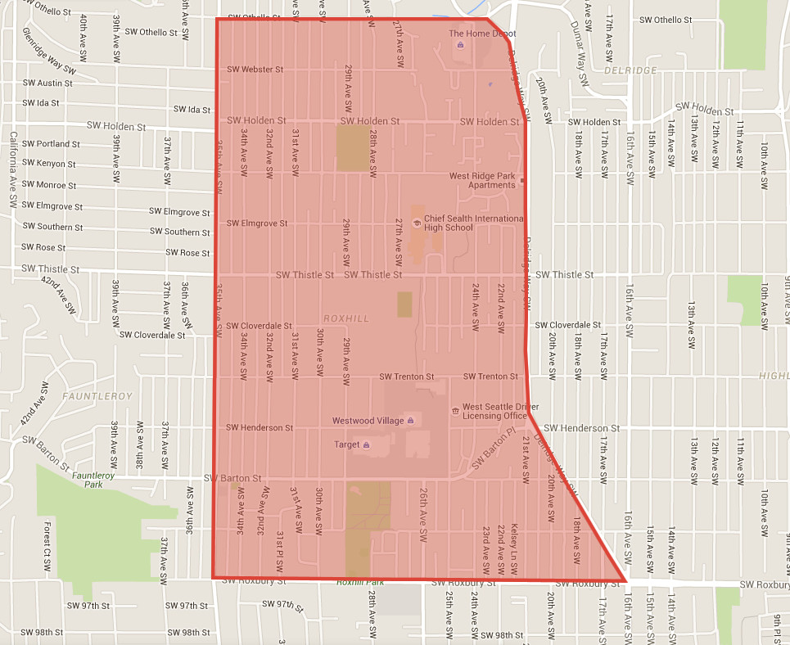

***The Roxhill/Westwood boundary is defined with red outline and fill.***